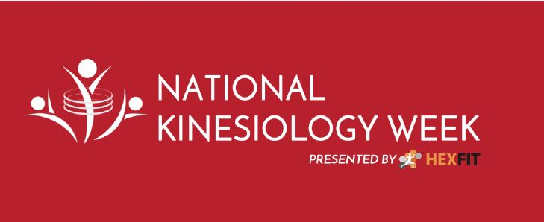
2018 National Kinesiology Week
November 12 to 18, 2018
Customizable E-blasts
Join us on Nov. 12th for the 2018 National KinWeek as Kinesiologists support the new and more inclusive paradigm shift in physical activity
Experts agree that nearly half of Canadian adults are not physically active enough to benefit their health and well-being, and despite many well-intended campaigns, this trend does not seem to be improving. This is why the Canadian Kinesiology Alliance (CKA), as part of the 2018 National Kinesiology Week (NKW) taking place from November 12 to 18, salutes the Let’s Get Moving report, the latest initiative from the Government of Canada to create a common vision where all Canadians move more and sit less, more often. It is only through the collaboration of the community, the government and private and public sectors, that physical activity will be increased and sedentary living reduced across all generations.
The 2018 NKW Campaign supports November Osteoporosis month and November 14th World Diabetes Day and will bring awareness of Kinesiology and perform community outreach activities in November.
Experts in human movement that use science and research to offer movement as medicine, such as kinesiologists, can contribute even more to society and act as agents of change towards a healthier population. Kinesiologists provide a hands-on, thorough and personalized approach, to offer movement as medicine to any person with a health and fitness goal, in an era where many practitioners spend less time with each patient and machines are performing more of the treatments. By working in collaboration with physicians, nurses, physiotherapists, occupational therapists, chiropractors and massage therapists, kinesiologists can significantly improve the health of their clients
To find out where activities are happening during National Kinesiology Week visit www.nationalkinweek.ca. In addition, visit www.cka.ca to watch a new series of videos on popular topics.
In [your event city], [your organization] will be hosting [the title of your event] encouraging all to get active by [your event details, i.e.: try riding a bicycle for the first time OR set a world record for most people skipping rope at one time]. Come meet a Kinesiologist near you.

Visit www.nationalkinweek.ca to browse a list of other local events happening in the community.
Note: Include a photo if you can.

See you then

(signature),
Affiliated Kinesiologist

