2019 National Health and Fitness Day
Kinesiologists encourage Canadians to be active!
Activity Ideas for Families
National Health and Fitness Day is an initiative to make Canada the Fittest Nation on Earth! Supported by kinesiologists and their professional health associations The Canadian Kinesiology Alliance. Saturday June 1st , 2019 provides an opportunity for all citizens to Get Up, Get Out and Get Active! The objective is to inspire Canadians to become fitter and more active which will result in reduced health care costs attributed to preventable diseases related to inactivity.

On Saturday June 1st get your kids, get your parents and get outside and get active! A family that plays together stays together! Here are some activity ideas for you and your family:
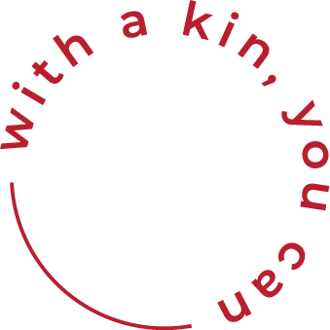
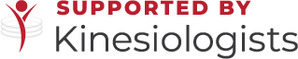

Family Fitness Ideas!

- Let your kids plan the activities for the day! If you’ve never played Grounders or Manhunt, you’re missing out! There are dozens of games available at BringBackPlay.ca
- Head to the park or playground and set up a fun obstacle course.
- Make a splash at your community pool or local recreation centre.
- Get together with neighbours for a game of all-ages ball hockey, races (egg-on-spoon; three-legged; and sack races); a scavenger hunt; a pool party; or a game of soccer.
- Fitness Bingo! Try it!
- Go for a walk – walk around the neighbourhood and discover a new park or ravine.
- Tour the community… on bikes.
- Take your dog for a long walk. Or, if you don’t have a dog – take your neighbour’s dog for a walk!
- Introduce the kids to something new. Bocce ball? Cricket?
- Spread the word! Help us engage all Canadians in National Health and Fitness Day. Spread the word on Facebook and Twitter. #NHFDcan #FittestNation
- Use hashtags and referrals: @CdnKinesiology.@NHFDcan #kinNHFD #onbouge #NHFDcan #FittestNation

Activity Ideas for Municipalities and Organizations

National Health and Fitness Day is an initiative to make Canada the Fittest Nation on Earth! Supported by kinesiologists and their professional health associations The Canadian Kinesiology Alliance. Saturday June 1st , 2019 provides an opportunity for municipalities to mark the day with local events to celebrate and promote the use of local health, recreational, sports and fitness facilities. Let’s inspire Canadians to become fitter and more active!

How Fit is your Community?

Looking for some ways to celebrate National Health and Fitness Day in your community? Consider some of these ideas:

- Encourage community recreation centres to waive the fees on Saturday June 1st .
- Offer family-friendly swim programming – all-ages aqua fit, intro to water polo, etc…
- Organize and host events in local parks – a scavenger hunt, nature walk, etc…
- Organize community soccer and baseball games for all ages and abilities.
- Encourage families to visit their local parks and playgrounds.
- Encourage local sports and recreational groups to offer information sessions, or “try it” days.
- Plan community fun fairs and use local parks to host multi-sport events for kids.
- Botanical societies can plan a local, neighbourhood garden tour.
- Take your classes outside – yoga, Zumba and cross fit can all be done in the park!
- Spread the word! Help us engage all Canadians in National Health and Fitness Day. Download the NHFD poster. Spread the word on Facebook and Twitter. #NHFDcan #FittestNation
- Use hashtags and referrals: @CdnKinesiology.@NHFDcan #kinNHFD #onbouge #NHFDcan #FittestNation

