2019 National Health and Fitness Day
Kinesiologists encourage Canadians to be active!
Customizable E-blasts
Blast #1
Join us on June 1st for National Health and Fitness Day and Let’s Make Canada the Fittest Nation on Earth!

National Health and Fitness Day is an initiative to make Canada the Fittest Nation on Earth! We want Canadians to come together on Saturday, June 1st , 2019 and get active!

Make sure you mark the day by visiting your community centre, participating in a local event, getting your family out to the park, or simply walking around the neighbourhood.

In [your event city], [your organization] will be hosting [the title of your event] encouraging residents to get active by [your event details, i.e.: try riding a bicycle for the first time OR set a world record for most people skipping rope at one time].

Make sure you take advantage of the day. Get Up, Get Out and Get Active and help make Canada the Fittest Nation on Earth!

Visit http://[your url] to browse a list of other local events happening in the community.
Note: Include a photo if you can.
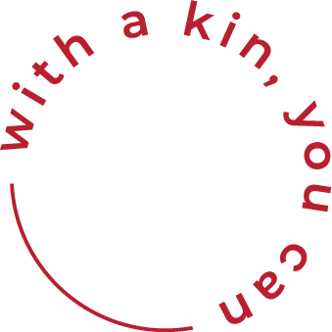

Blast #2
Celebrate National Health and Fitness Day on June 1st and Get Up, Get Out, and Get Active!

After years of working with local community groups and national health promotion organizations to review ways of improving health and fitness in Canada, Senator Nancy Greene Raine saw passage of Bill S-211, the National Health and Fitness Day Act, in December 2014. The passage of the Bill creates a strong impetus towards bringing communities together every year on the first Saturday in June, to highlight the importance of Health and Fitness.

Hundreds of municipalities across the country from east to west to north have proclaimed the day and are planning to celebrate the day by hosting activities, promoting the use of local health, recreation, sports and fitness facilities, as well as simply encouraging people to Get Up, Get Out and Get Active!

In [your event city], [your organization] will be hosting [the title of your event] encouraging residents to get active by [your event details, i.e.: try riding a bicycle for the first time OR set a world record for most people skipping rope at one time].

Visit http://[your url] to browse a list of other local events happening in the community.
Note: Include a photo if you can.

