2019 National Health and Fitness Day
Kinesiologists encourage Canadians to be active!
Media Advisory
[Media Advisory - instructions to event organizer: fill out yellow sections and e-mail to local news
contacts approximately five days before your event.]

[Insert your organization’s logo here]

FOR IMMEDIATE RELEASE

GET UP, GET OUT and GET ACTIVE
On National Health and Fitness Day, Saturday June 1st, 2019

[Organization] is taking part in National Health and Fitness Day

City Name (Province/Territory) Date – To mark this year’s National Health and Fitness Day, an initiative to make Canada the Fittest Nation on Earth, [your organization] is hosting [insert a short description of your event.]

National Health and Fitness Day is an initiative to make Canada the fittest nation on earth! The day, June 1st , 2019, provides an opportunity for municipalities and all citizens to mark the day with local events to celebrate and promote the use of local health, recreational, sports and fitness facilities. The objective is to inspire Canadians to become fitter and more active which will result in reduced health care costs attributed to preventable diseases related to inactivity. This initiative is supported by kinesiologists and their professional health associations.

[Insert quote from your organization about why you’re excited to participate in NHFD. For example: “We’re thrilled to take part in NHFD and want to encourage all Canadians to be more active ….,” says [insert name, title]. “The city of ___________ has a long tradition of supporting health and fitness. Physical activity is great for our community and is something we can all get behind.”]

WHAT:

WHEN:

WHERE:

WHO: [name key individuals who will attend the event – Mayor, Celebrity, City Official…]

About National Health and Fitness Day
After years of working with local community groups and national health promotion organizations to review ways of improving health and fitness in Canada, Senator Nancy Greene Raine saw passage of Bill S-211, the National Health and Fitness Day Act, in December 2014. The passage of the Bill creates a strong impetus towards bringing communities together every year on the first Saturday in June, to highlight the importance of Health and Fitness.

Currently hundreds of municipalities across the country from east to west to north have proclaimed the day and are planning to celebrate the day by hosting activities, promoting the use of local health, recreation, sports and fitness facilities, as well as simply encouraging people to Get Up, Get Out and Get Active!
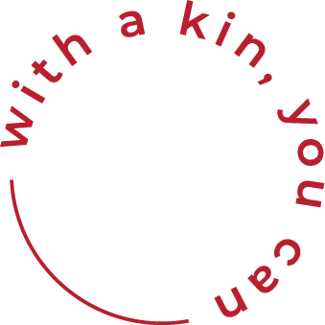

About Your Organization:
Add boiler plate content

- 30 ‐

For more information or to speak to a spokesperson, please contact:

Your name
Your organization
Include your web address for more information.
Your telephone number
Your e-mail address

